Worker signup/onboarding flow:
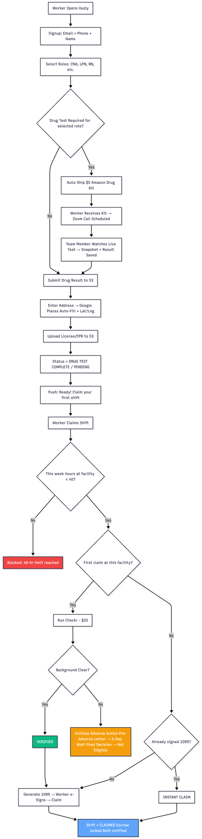

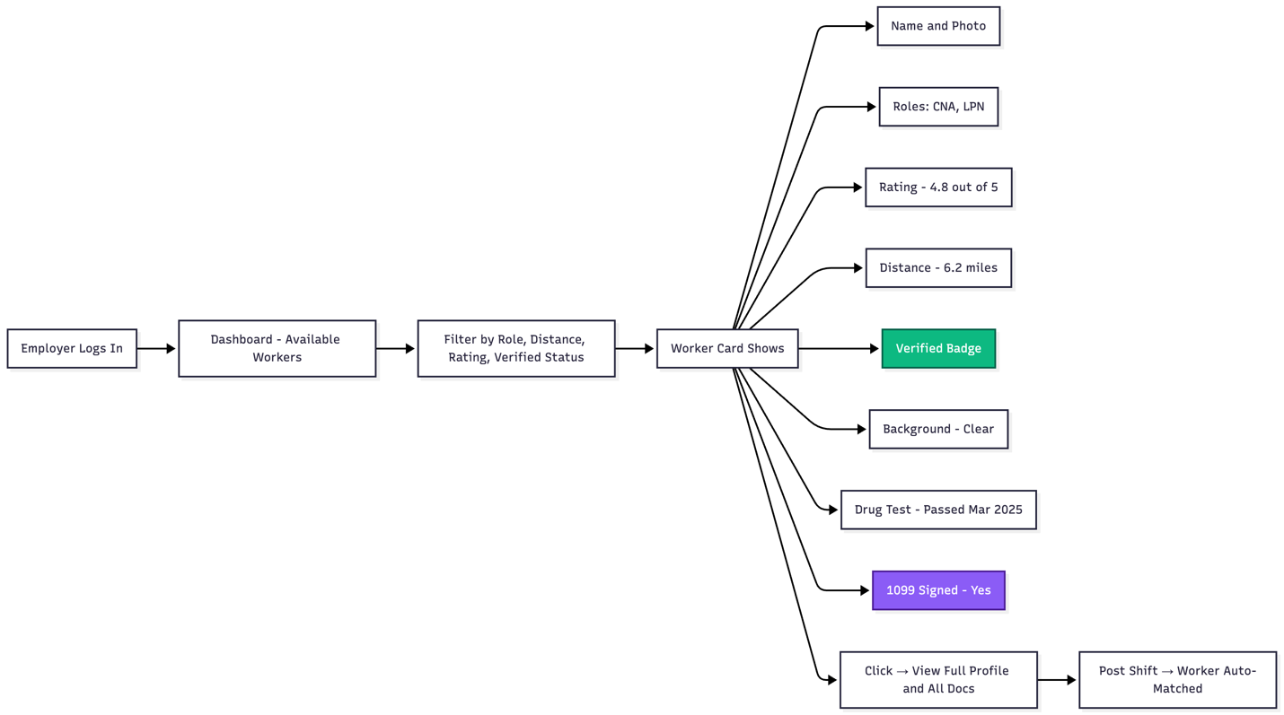

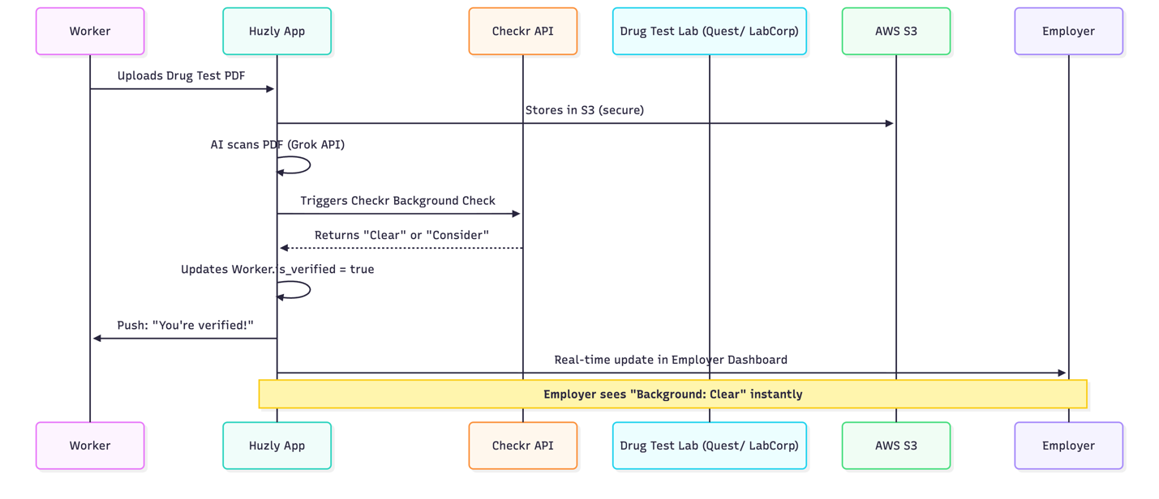

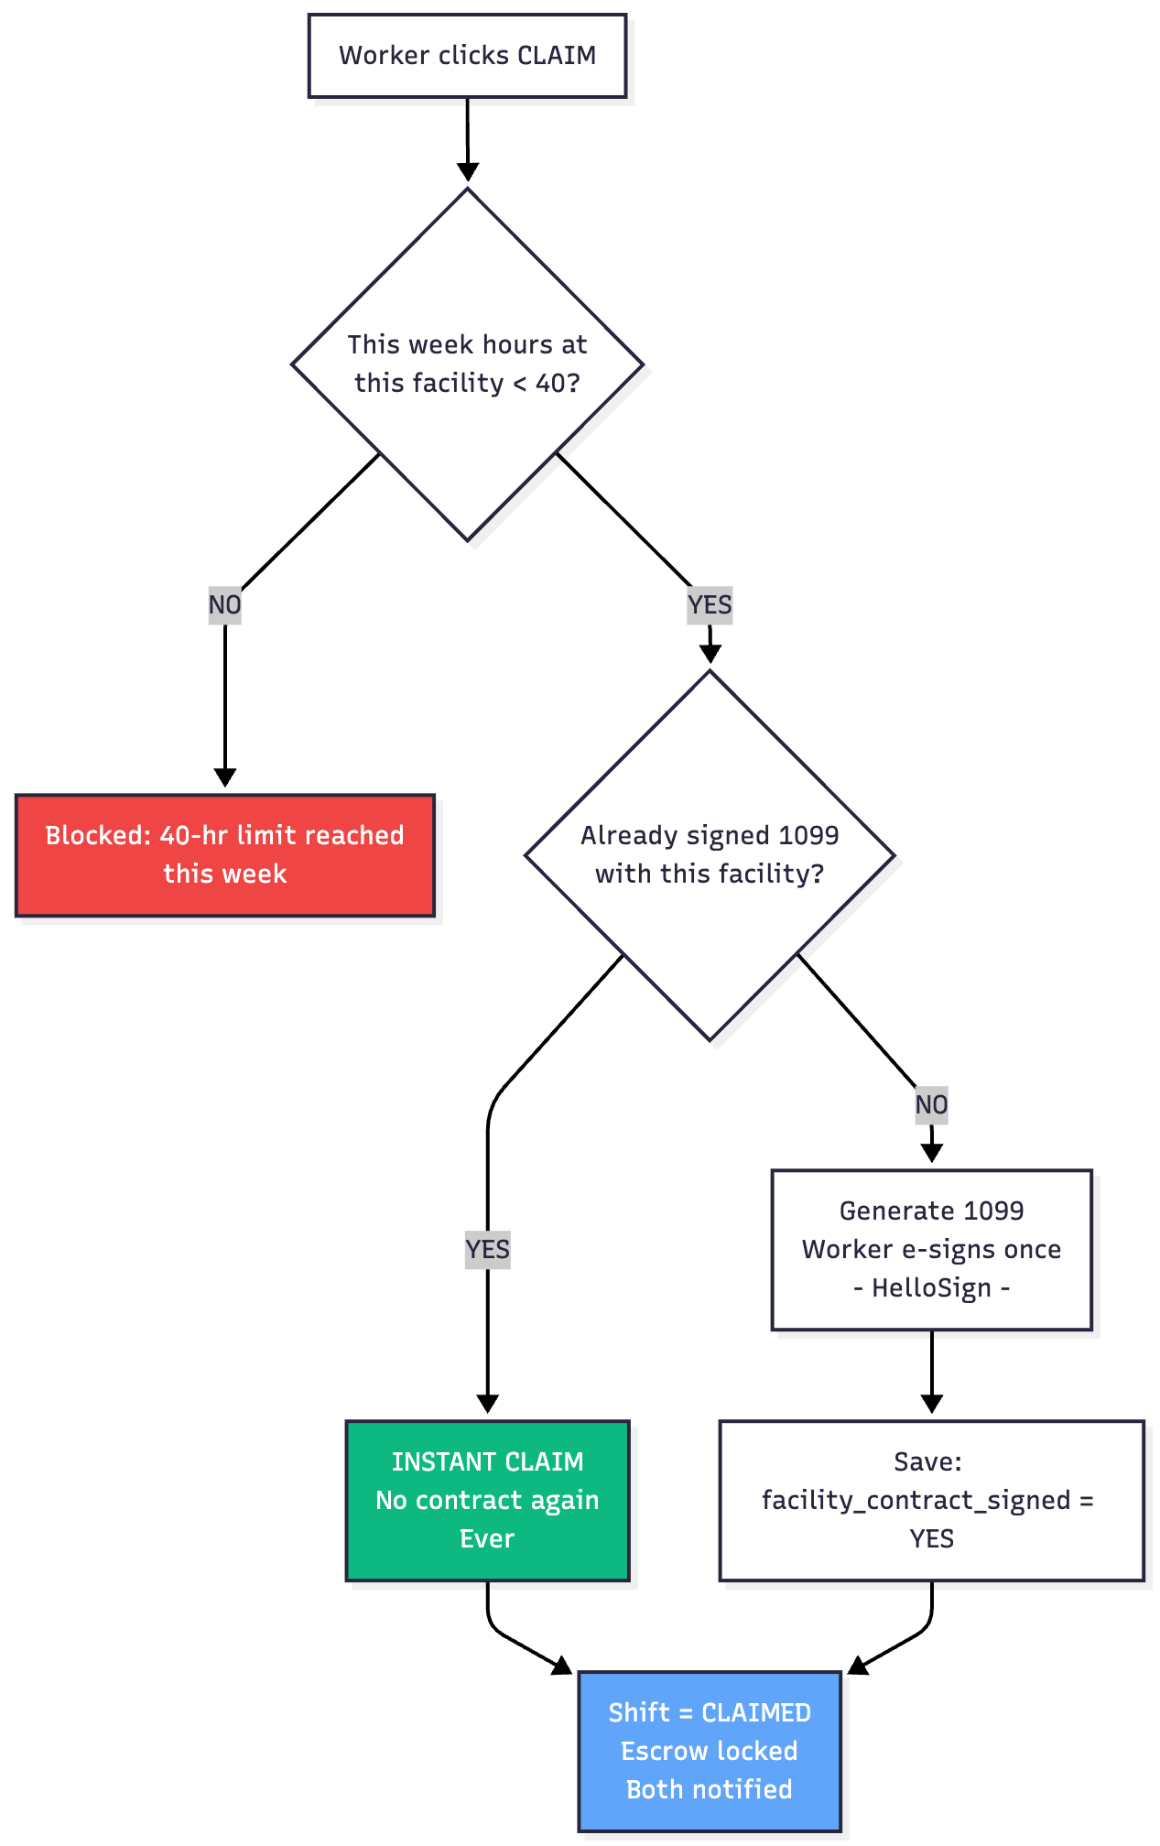

MVP-1 Worker Onboarding Flow (Updated for Offshore Manual Verification – No Checkr)
Here is the 100% accurate, current flow for MVP-1 (aligned with your offshore team doing background checks + state license verification instead of Checkr).
Screen | Title | What Happens | Data Captured | Verification Status
1 | Sign-Up | Email + Phone + Name + Password | user table (role = Worker) | is_verified = false
2 | Role & Sector | Pick one or more roles (CNA, Picker, Housekeeper, etc.) + sector toggle | user.sector_preference + custom roles array | —
3 | Upload Documents (Healthcare roles only) | License, ID, CPR, Resume – drag & drop | credential table (encrypted URLs) | flagged for offshore team
4 | Background Consent | Consent form + last 4 SSN + address (for manual check) | Consent flag + partial SSN | flagged for offshore team
5 | Review & Submit | Summary of everything → “Submit for Verification” | All locked | Status = Pending Offshore Review
6 | Verification Dashboard (Worker View) | “Your profile is being reviewed” → live status updates | Real-time from Supabase | Shows: • Documents – Under review • Background – Under review • Estimated: 24–72 hrs
7 | Approved! | Push notification + email → “You’re verified!” | user.is_verified = true | Worker can now browse/claim shifts
Offshore Team Process (MVP-1)
- New worker submission → appears in Admin → Pending Workers panel
- Team member opens profile → downloads docs → manually checks state license boards (NURSYS, etc.)
- Runs background check via your offshore provider
- Marks each item Approved / Rejected with notes
- Clicks “Verify Worker” → Supabase updates is_verified = true → worker gets instant access

